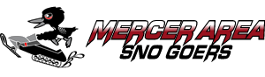
Mercer Area Sno-Goers
Board Meeting Agenda
Tuesday October 25th, 2022 ~ 9AM ~ The Barn
- Call to Order
- Roll Call
- Pledge of Allegiance
- Approval of the Agenda
- Approval of Minutes
- Treasurer’s Report
- Membership Chairperson Report
- Public Relation Report
- Sign Master Report
- Trail Administrator Report
- Trail Boss Report
- Directors Reports
- Darrell
- Steve
- Kyle
- Gary
- Vice Presidents Report
- Presidents Report
- Scholarship Chairman
- Old Business
a) AWSC workshop report
b) National Snowmobile Day October 29
c) Sled Raffle
d) Little Ripper Report
e) Trail changes/reroutes update
- New Business
a) Snowmobile Friendly Community
b)
- Adjournment

Our Mission
Making the Best Trails Better

